项目：[VolantMQ/volantmq [891 stars]](https://github.com/VolantMQ/volantmq)

注：我们已向厂商通报此安全问题

#### 0x01 攻击场景

* **攻击场景**

首先，攻击者通过猜测或是受害者泄露得到了受害者的clientID，并且攻击者是一个无权限的状态  
  
  
1. 攻击者使用相同的clientID，并且以“Clean Start = False”连接broker。  
  
2. broker会触发take over机制，将已存在的受害者session踢下线，并且将受害者session中保存的(1. 订阅关系；2. 未完成的消息)保存到新的session中。  
  
3. broker随后触发受害者的will message。  
  
4. 恶意的will message被投递到订阅者。  
  
5. 攻击者继承受害者的订阅关系，无需任何权限便能继续接收消息。

* **漏洞危害**

1. 攻击者能继承受害者的订阅关系，能直接收取消息，而无需subscribe权限去订阅topic
2. DoS攻击，将相同clientID的受害者踢下线
3. 恶意的will message，虽然攻击者无法控制will message的内容，但是能选择触发该will message的时机，并且攻击者本身对于该will message没有权限，是一种越权行为。
4. 攻击者能够继承受害者的消息队列(QoS1/2)

#### 0x02 漏洞测试步骤

* **测试环境**

**VolantMQ**: 0.4.0

**mqtt client**: 任意客户端即可 (paho.mqtt)

**访问控制插件**: 官方插件[http auth]([VolantMQ / vlplugin / Auth / http · GitLab](https://gitlab.com/VolantMQ/vlplugin/auth/http))（由于golang更新已不再支持plugin模块，因此这个插件目前无法使用），也可修改VolantMQ内置的auth测试插件 (见附录auth.go, 替换cmd/volantmq/auth.go)，由于漏洞的原理为broker的permission check位置不当 (或没有进行足够的检查)，而无关于permission check本身的正确与否，因此无论权限检查插件使用何种机制 (使用http请求授权服务器、使用database存储ACL等)，漏洞本身都是存在的。

配置测试用户：

admin: 拥有所有权限

user1(attacker): **没有任何权限**

配置文件如下：

version: v0.0.1  
system:  
 log:  
 console:  
 level: info # available levels: debug, info, warn, error, dpanic, panic, fatal  
 http:  
 defaultPort: 8080  
plugins:  
 enabled:  
 - auth_http  
 config:  
 auth: # plugin type  
 - name: internal  
 backend: simpleAuth  
 config:  
 users:  
 admin: "d74ff0ee8da3b9806b18c877dbf29bbde50b5bd8e4dad7a3a725000feb82e8f1" # pass  
 user1: "e6c3da5b206634d7f3f3586d747ffdb36b5c675757b380c6a5fe5c570c714349" # pass1  
auth:  
 anonymous: false  
 order:  
 - internal  
mqtt:  
 version:  
 - v3.1.1  
 - v5.0  
 keepAlive:  
 period: 60 # KeepAlive The number of seconds to keep the connection live if there's no data.  
 # Default is 60 seconds  
 force: false # Force connection to use server keep alive interval (MQTT 5.0 only)  
 # Default is false  
 options:  
 connectTimeout: 5 # The number of seconds to wait for the CONNECT message before disconnecting.  
 # If not set then default to 2 seconds.  
 offlineQoS0: true # OfflineQoS0 tell server to either persist (true) or ignore (false) QoS 0 messages for non-clean sessions  
 # If not set than default is false  
 sessionPreempt: true # Either allow or deny replacing of existing session if there new client with same clientID  
 # If not set than default is false  
 retainAvailable: true # don't set to use default  
 subsOverlap: true # tells server how to handle overlapping subscriptions from within one client  
 # if true server will send only one publish with max subscribed QoS even there are n subscriptions  
 # if false server will send as many publishes as amount of subscriptions matching publish topic exists  
 # Default is false  
 subsId: true # don't set to use default  
 subsShared: false # don't set to use default  
 subsWildcard: true # don't set to use default  
 receiveMax: 65530 # don't set to use default  
 maxPacketSize: 268435455 # don't set to use default  
 maxTopicAlias: 65535 # don't set to use default  
 maxQoS: 2  
listeners:  
 defaultAddr: "0.0.0.0" # default 127.0.0.1  
 mqtt:  
 tcp:  
 1883:  
 auth:  
 tls:  
 ws:  
 8883:

若使用[http auth]([VolantMQ / vlplugin / Auth / http · GitLab](https://gitlab.com/VolantMQ/vlplugin/auth/http))或是附录中的auth.go，则仅需简单写一个http服务 (见附录app.py)，在broker请求/acl页面获取用户是否拥有进行敏感操作的权限时，回复"allow" (代表拥有权限)/"xxxxx"即可。

from flask import Flask, request, render_template, session, jsonify  
from flask_cors import CORS, cross_origin  
import json  
import time as mytime  
from datetime import *  
  
app = Flask(__name__)  
cors = CORS(app)  
  
  
@app.route('/acl', methods=['GET'])  
def Start():  
 user = request.args.get('user')  
 resp = "deny"  
 if(user == "admin"):  
 resp = "allow"  
 elif(user == "user1"):  
 resp = "allow"  
 return resp  
  
  
if __name__ == '__main__':  
 app.run(host='0.0.0.0', debug=True, port=80)

* **测试步骤**

1. 观察者登录（admin）

clientID: "inspector"

订阅topic: "test"

$ mosquitto_sub -u admin-user -P admin-password -t "test"

1. 受害者登录 (admin)

clientID: "cid"

will message: "mywill"

will topic: "test"

$ mosquitto_sub -i cid -t "test" -u admin-user -P admin-password --will-topic "test" --will-payload "mywill"

1. 攻击者登录 (attacker)

clientID: "cid"

$ mosquitto_pub -i cid -u user1 -P pass1 -t "test" -m "bad"

随后受害者will message "mywill"被inspector接收到

#### 0x03 漏洞原理分析

1. 当broker向订阅者投递普通消息/retained message时，即没有检查发布者权限（仅在收到PUBLISH报文时检查，在收到PUBREL报文开始投递时没有检查），也没有检查订阅者是否拥有接收消息的权限

connection\session.go: 93

// SignalPublish process PUBLISH packet from client  
func (s *session) SignalPublish(pkt *mqttp.Publish) error {  
 pkt.SetPublishID(s.subscriber.Hash())  
  
 // [MQTT-3.3.1.3]  
 if pkt.Retain() {  
 if err := s.messenger.Retain(pkt); err != nil {  
 s.log.Error("Error retaining message", zap.String("clientId", s.id), zap.Error(err))  
 }  
 }  
  
 if err := s.messenger.Publish(pkt); err != nil {  
 s.log.Error("Couldn't publish", zap.String("clientId", s.id), zap.Error(err))  
 }  
  
 return nil  
}

1. 在发生session take over (MQTT spec定义的合法行为)时，没有进行检查新的session是否拥有exist session相关资源(例如订阅关系)的权限

connection\sessions.go: 351

if ch, e := cn.Accept(); e == nil {  
 for dl := range ch {  
 var resp mqttp.IFace  
 switch obj := dl.(type) {  
 case *ConnectParams:  
 connParams = obj  
 resp, acl, e = m.processConnect(connParams, authMngr)  
 case AuthParams:  
 resp, e = m.processAuth(connParams, obj)  
 case error:  
 e = obj  
 default:  
 e = errors.New("unknown")  
 }  
  
 if e != nil || resp == nil {  
 cn.Stop(e)  
 cn = nil  
 return nil  
 }  
  
 if resp.Type() == mqttp.AUTH {  
 _ = cn.Send(resp)  
 } else {  
 ack = resp.(*mqttp.ConnAck)  
 break  
 }  
 }  
 }

#### 0x04 漏洞效果

##### 测试前配置

测试用的账号：admin和user1

目前user1没有任何权限

#app.py  
@app.route('/acl', methods=['GET'])  
def Start():  
 user = request.args.get('user')  
 resp = "deny"  
 if(user == "admin"):  
 resp = "allow"  
 elif(user == "user1"):  
 resp = "deny"  
 return resp

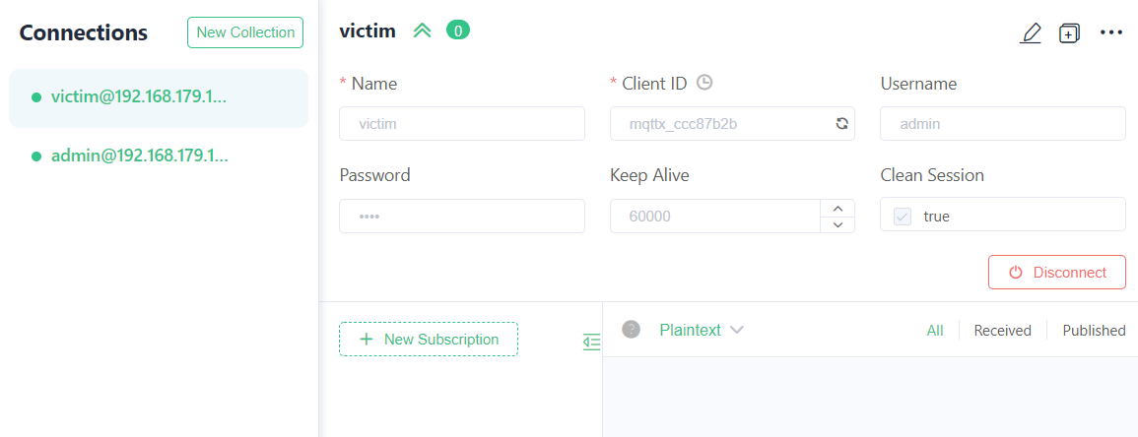

##### 测试流程

1. 观察者登录（admin）

clientID: "mqttx_1b8fa4f7"

订阅topic: "test"

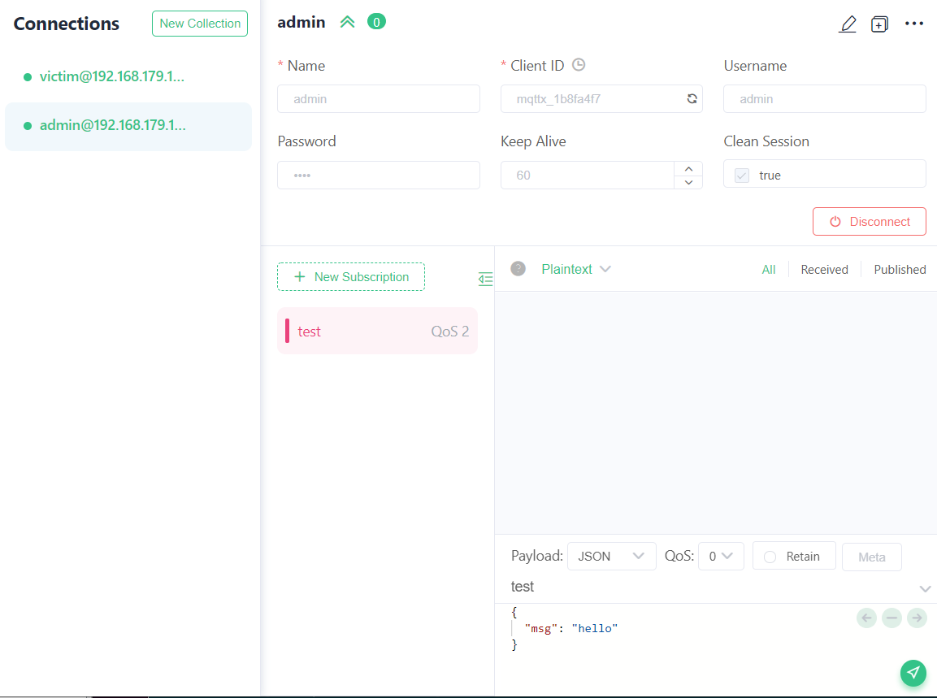

1. 受害者登录 (admin)

clientID: "victim"

will message: "will"

will topic: "test"

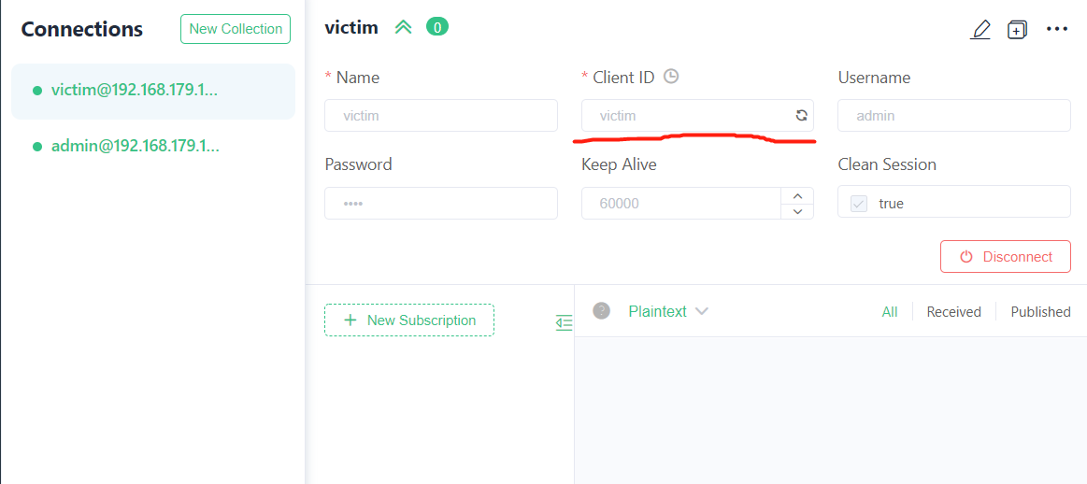

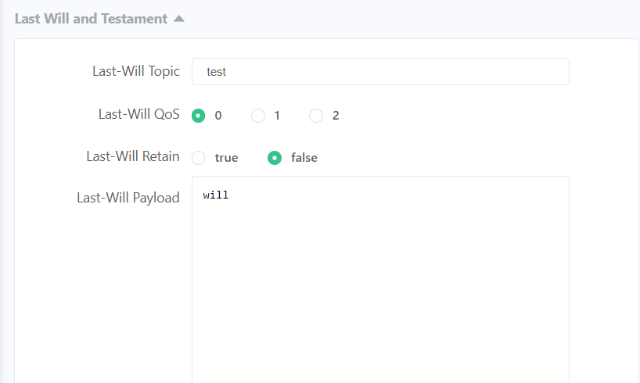

1. 攻击者登录 (attacker)

clientID: "victim"

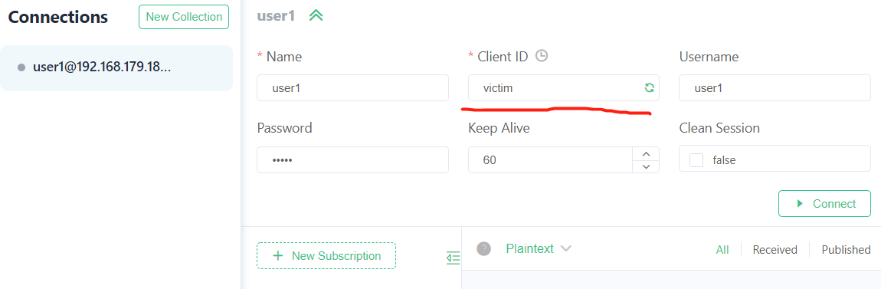

随后受害者被抢占下线, 并且它的will message "will"被inspector接收到

